Surgical Robotics Environment for NVIDIA Isaac Sim

EN.601.456.01.SP24 Computer Integrated Surgery II

#### Team #8 Project Proposal

Tae Wan Kim (tkim104@jhu.edu)

February 22nd, 2024

# **Table of Contents**

### **1.** Introduction…………………………………………………………………….. 2

### **2.** Background and Significance………………………………………………….. 2

### **3.** Prior Work……………………………………………………………………… 3

### **4.** Goals…………………………………...………………………………………. 4

### **5.** Technical Approach…………………..……………………………………….. 4

### **6.** Key Deliverables……………………………………………………………….. 6

### **7.** Dependencies……………………………………………………………….... 7

### **8.** Timeline……………………………………………………………………… 8

### **9.** Members, Mentors, and Roles……………………………………………….. 9

### **10.** Management Plan……………………………………………………………... 9

### **11.** Reading List……………………………………………………………….. 10

### **12.** References…………………………………………………………………. 11

## **1. Introduction**

The main goal of this project is to discover the potential and limits in using NVIDIA's Isaac Simulator for developing surgical robotics environments. Currently, one of the main simulators used for research at Johns Hopkins is known as the Asynchronous Multi-Body Framework (AMBF) developed by Dr. Adnan Munawar and we hope to compare the simulators' performance to better understand the capabilities of Isaac Sim.

## **2. Background and Significance**

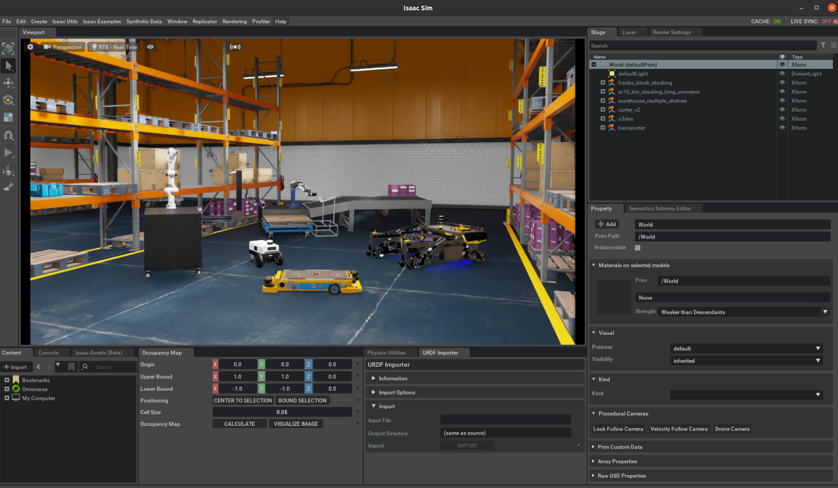

*Figure 1. Omniverse Isaac Sim GUI [6]*

Robotics simulators are used in a wide range of fields from government applications in motion to manipulators used for industry [1]. There is a great amount of literature on the field as a whole, however our project focus targets medical robotics used in surgical applications. Currently, research and development in accurate surgical robotics simulators provide a platform for users to experiment with design and testing before physically creating a product. This primarily reduces the cost and time involved in developing a new surgical robotic device that creators can test without the need to use live testing as much. Relying on the precision and models developed on these simulator platforms, developers have used simulators to further develop the tools to help the surgeon or medical practitioner in their work. By reducing the possibility of tremor, surgery fatigue, and alleviating burdens to the device's user, surgical robotics have become a useful tool to drive better patient outcomes in medicine [2].

Medical or surgical robotics research is a sub-discipline in overall robotics research, thus requiring simulators to have certain features. Most commonly, if a robot is to be teloperated by a surgeon on a patient, simulators used to develop it would require excellent soft-body calculations, real-time reply, and force/torque feedback for haptic control [1]. Thus, the simulator would then need to model and mimic the real environment for proper development and, more recently, synthetic data creation for training models with machine learning, neural networks, and reinforcement learning to name a few.

*Asynchronous Multi-Body Framework AMBF:*

Developed in 2019, AMBF has been an established surgical robotics simulator with the ability to define the simulation space in its custom AMBF Description Format (ADF). This format aims to retain all the necessary information and relationships in a well-defined robotic device while keeping its file human readable, constraint handling, and maintain contralibility to name a few features. The simulator itself is able to conduct soft body calculations, and supports teloperation and haptic feedback [3].

*NVIDIA Isaac Sim:*

Originally launched in 2021 in its Beta, Isaac Sim is a more general robotics environment simulator used in a wide-range of applications not just focused in the surgical sphere. Currently, it is on version 2023.1.1 and allows the user to simulate a multitude of features on its PhysX 5 physics engine and portray high fidelity, highly realistic images with its Omniverse RTX renderer [4]. Utilizing the Universal Scene Descriptor file format, Isaac Sim also has full dynamic modeling and supports connections using the Robot Operating System (ROS) as well.

## **3. Prior Work**

Several papers and research studies have already been done with AMBF, more recently is the its use seen with the Surgical Robotics Challenge:

|  |  |
| --- | --- |

*Figure 2. Surgical Robotics Challenge in AMBF 2023-2024 (600.456/496/656 CIS2 Spring 2024 Copyright R. H. Taylor)*

The platform has also been used in reinforcement learning and has seen continued use in the surgical simulator space with several projects developing with AMBF [5].

On the other hand, multiple industries have already begun using Isaac Sim and have seen research into its development. One group from the University of Toronto has developed a unified simulation framework using Isaac Sim known as ORBIT, which serves as an important reading on the use of Isaac Sim moving forward [4].

## **4. Goals**

Broadly, the primary goal is to understand how Isaac Sim could be used as a robotics simulator in the context of a surgical robotics environment, finding out what features it can do well and what it may lack. In more specifics, this goal can be broken down to three sub-goals to achieve for this project in gaining expertise, understanding its performance, and where it could be used.

*Sub-Goal Success Requirements:*

* Gaining Expertise
  + Recreation of the Surgical Robotics Challenge done in AMBF
* Performance Analysis
  + Quantitative and Qualitative Performance report between Isaac Sim and AMBF
* Application
  + Possible use in Sim2Real transfer or ROS/ROS2 connection

The third goal is highly dependent and mutable depending on the results of the first and second goals that would need to be addressed before accurately determining what success would look like for the Application goal.

## **5. Technical Approach**

*General Overview:*

The project has been organized to 3 distinct stages that requires the previous stage to be near completion before the next stage can truly begin. Overall, we take a simple exploratory approach to discover what NVIDIA's Isaac Sim can do and then compare its performance to an established simulator we have used in the past for other experiments. Finally, depending on the results of the first two stages, we then can apply Isaac Sim to an application beyond analysis of the simulator itself. This will likely be done either with Sim2Real transfer of a tool/needle while interacting with the model or go further into customizing the software of Isaac Sim for research use.

*Stage 1: Building Expertise:*

Building expertise will require the user to familiarize themselves with the Isaac Sim program and be able to use the NVIDIA Omniverse environment as well. At the same time, this will require extensive but concise documentation on the installation and use of Isaac Sim for future users of the platform for surgical robotics applications or research. Several competencies required would include:

* Asset Conversion / Creation / Manipulation
* Controlling a Scene description by filling out an environment in the model
* Utilizing sensor creation for synthetic data generation

While development of Isaac Sim is the focus, near the end of the stage, it will be necessary to begin understanding the potential and limits the simulator may have.

*Stage 2: Performance Analysis:*

To serve as a point of comparison, we would then compare the performance of Isaac Sim to AMBF. While the scope of the project does not aim to contrast the differences different hardware specifications may have to the simulators performance, we do hope to illuminate their specs on what features they provide and how well they provide given the following specifications and more:

* Minimum Hardware Specs ( Deployability )
* FPS Throughput for different dynamics calculations
  + Ridge Body Simulations
  + Soft Body Simulations
  + Deformable
  + Fluid
* Realism fidelity ( Likert Scale; dependent on mentor expertise )
* Rendering Speeds (FPS)
* Mutability
  + How well can one customize objects, dynamics, sensors, meshes, and more
* Interaction
  + Communication between the simulator and other devices, whether surgical machines or in control devices with haptic feedback
* Real-time

*Stage 3: Possible Applications:*

Currently this stage is highly dependent on the results of the first two stages. However, we can currently understand that Isaac Sim should be suitable for a Sim2Real transfer segmentation model development given time. This would require utilizing the expertise gained on Isaac Sim and developing software and procedures to teach a model to use a surgical robot in Isaac Sim and then transferring that knowledge onto a real machine after extensive training on a simple task. This task will likely conclude with a needle/tool segmentation model of a program grabbing a needle and guiding it through an object.

Other possible applications to pursue would include using a ROS/ROS2 connection between Isaac Sim and another device with ROS such as the da Vinci Robot Toolkit (dVRK) or creating a joint pipeline between Isaac Sim and AMBF if one simulator proves to have a better physics engine and the other may have a more desirable rendering pipeline. While possible applications to explore are highly dependent, formal decisions will have to come in the performance report between Isaac Sim and AMBF.

## **6. Key Deliverables**

|  | Deliverables | Deliverable Type |
| --- | --- | --- |
| Minimum | Isaac Sim Custom User Guides for future usage (installation for JHU systems, execution, and setup) |  |
| Initial Performance Report on Isaac Sim capabilities and limitations |  |
| Replication of Surgical Robotics Challenge 2023-2024 seen in AMBF |  |
| Code and Documentation for Universal Scene Descriptor (USD), Unified Robotics Description Format (URDF), and AMBF Description Format (ADF) possible converters |  |
| Expected | AMBF Analysis / Technical Summaries (While expected to be written by student, still will require mentor expertise) |  |
| Performance Report between Isaac Sim and AMBF |  |
| Demonstration of Isaac Sim and AMBF similarities and differences |  |
| Maximum | Sim2Real transfer with tool/needle segmentation model |  |
| ROS / ROS2 connection between Isaac Sim and the da Vinci Research Kit (dVRK) |  |
| Split Pipeline control between Isaac Sim and AMBF (Technical Report, code, and documentation) |  |

*Figure 3. General Dependencies Table with Deliverable Type (Document, Code, Video)*

Notes: The maximum deliverables are highly dependent on the results of the minimum and expected deliverables as the discovered possibilities one can use with Isaac Sim may or may not allow certain activities to be done. More specifications on which maximum to pursue will be considered at a later date (no later than April 10th).

## **7. Dependencies**

While the project is mainly done virtually, several critical dependencies are needed to begin analysis of Isaac Sim and develop the comparisons between simulators:

*General Dependencies:*

| **Dependencies** | **Purpose** | **Status** | **Hard Deadline** | **Curr. Priority** | **Alternatives** |
| --- | --- | --- | --- | --- | --- |
| *Desktop System* | To run Isaac Sim and conduct exploratory work | In Progress | February 26th | ↑↑↑↑↑ | Robotorium Computers  Cloud Containers  Mentor's Computer |
| *Robotorium Access* | To use powerful enough desktop for Isaac Sim | Complete | February 19th | ↑ | Remote Access to desktop  Cloud Access |
| *Robotorium Comp. Account* | To use Robotorium Computers | Complete | February 19th | ↑ | Personal Account  Mentor's Account |
| *Isaac Sim License* | Access to NVIDIA Omniverse and Isaac Sim environment | Complete | February 26th | ↑↑↑ | Isaac Sim Enterprise  Isaac Sim Cloud |
| *AMBF-Expertise* | Expertise to run and gather AMBF statistics to compare | Complete | March 20th | ↔ | AMBF Wiki 2.0 and github  Mentor Expertise |
| *3D Assets* | Surgical Challenge Assets and Files | Complete | March 2nd | ↑↑ | USD File Recreation  Blender Assets |

*Critical Dependency Specifications:*

The NVIDIA Isaac Sim requires specific high-powered specifications to run on a desktop workstation set up, more so if one wishes to run NVIDIA Omniverse and Isaac Sim optimally to acquire the best results when testing the capabilities of the program. The core specs can be found here on NVIDIA's website:

https://docs.omniverse.nvidia.com/isaacsim/latest/installation/requirements.html

## **8. Timeline**

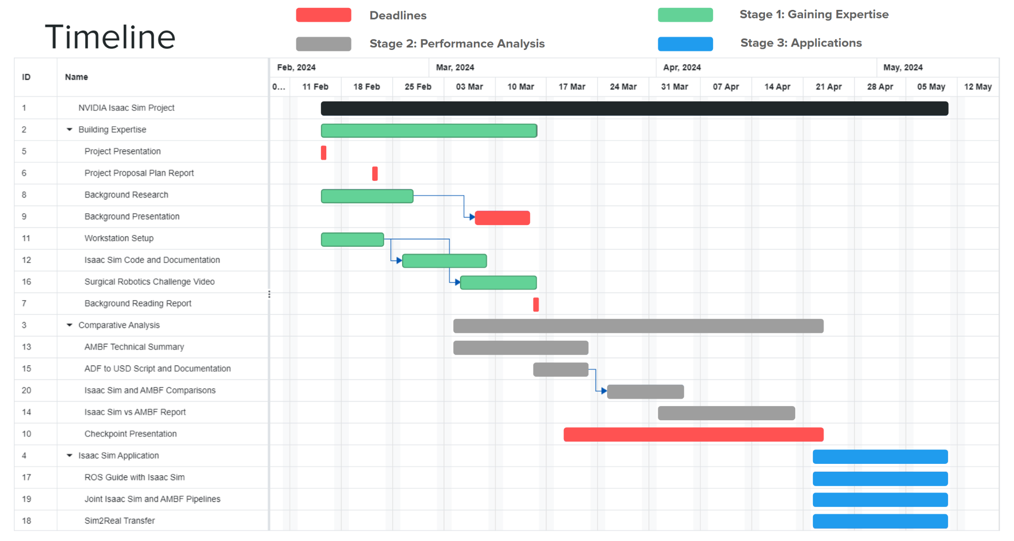

The primary timeline is broken down to 3 stages aligned with the 3 levels of deliverables presented for this project. Critical deadlines are highlighted in red for their estimated due date that are to be determined at a later date so far. A bulk of the project will be concentrated on the comparison between AMBF and Isaac Sim.

## **9. Members, Mentors, and Roles**

*Student Members:*

* **Tae Wan Kim** (tkim104@jhu.edu)

*Undergraduate, BME / CS*

Is primarily responsible for bringing the NVIDIA Isaac Sim project and applications to a usable state for the lab, in charge of finding and documenting the Isaac Sim performance and results between simulator comparisons.

*Mentors:*

* **Hisashi Ishida** (hishida3@jhu.edu)

*Graduate (PHD) Student, CS*

* **Juan Antonio Barragan** (jbarrag3@jhu.edu)

*Graduate (PHD) Student, CS*

* **Jintan Zhang** (jzhan247@jhu.edu)

*Graduate (PHD) Student*

* **Dr. Adnan Munawar** (amunawa2@jh.edu)
* **Dr. Peter Kazanzides** (pkaz@jhu.edu)

## **10. Management Plan**

*Meetings:*

There is a joint meeting between Team # 8: Surgical Robotics Environment for NVIDIA Isaac Sim and Team # 12 Digital Playground for developing medical robotics environment that occurs every Friday, 2:00 - 3:00 pm as the mentors for both projects are shared. At the same time, the mentors have provided schedulable meeting times throughout the week if necessary.

*Platforms:*

* Communication
  + Microsoft Teams: Primary way of communication in a Microsoft Teams channel between the student and mentors.
  + Email and Outlook: Additional way for communication between student and mentors, used as needed if Microsoft Teams is insufficient.
* Documentation
  + Microsoft Teams: File sharing done in the teams channel for mentors to review student produced work.
  + Google Docs: Student documentation, drafts, and notes in private google docs account, shared through Teams for mentors.
  + Github: Private repository will be made to store any produced code and code write up during the project.

## 

## **11. Reading List**

**Quiroz Omaña**, J. J., Marques Marinho, M., & Harada, K. (2023). *Digital Twin of a Multi-Arm Robot Platform based on Isaac Sim for Synthetic Data Generation* (Version 1.0.0) [Data set]. Zenodo. <https://doi.org/10.5281/ZENODO.7860757>

**Mittal, M**., Yu C., Liu, J., Rudin, N., Hoeller, D., Yuan, J., Tehrani, P., Singh, R., Guo, Y., Mazhar, H., Mandlekar, A., Babich, B., State, G., Hutter, M., & Garg, A. (2023). *ORBIT: A Unified Simulation Framework for Interactive Robot Learning Environments.* [arXiv:2301.04195](https://arxiv.org/abs/2301.04195) [cs.RO]. <https://doi.org/10.48550/arXiv.2301.04195>

**Schmidgall, S**., Krieger, A., & Eshraghian, J. (2024). *Surgical Gym: A high-performance GPU-based platform for reinforcement learning with surgical robots.* [arXiv:2310.04676](https://arxiv.org/abs/2310.04676) [cs.RO]. <https://doi.org/10.48550/arXiv.2310.04676>

**V. M. Varier,** D. K. Rajamani, F. Tavakkolmoghaddam, A. Munawar and G. S. Fischer, *"AMBF-RL: A real-time simulation based Reinforcement Learning toolkit for Medical Robotics,"* *2022 International Symposium on Medical Robotics (ISMR)*, GA, USA, 2022, pp. 1-8, doi: 10.1109/ISMR48347.2022.9807609.

**A. Munawar**, J. Y. Wu, G. S. Fischer, R. H. Taylor and P. Kazanzides, "Open Simulation Environment for Learning and Practice of Robot-Assisted Surgical Suturing," in *IEEE Robotics and Automation Letters*, vol. 7, no. 2, pp. 3843-3850, April 2022, doi: 10.1109/LRA.2022.3146900.

**Zhou, Zhehua** & Song, Jiayang & Xie, Xuan & Shu, Zhan & Ma, Lei & Liu, Dikai & Yin, Jianxiong & See, Simon. (2023). Towards Building AI-CPS with NVIDIA Isaac Sim: An Industrial Benchmark and Case Study for Robotics Manipulation.

**J. Collins**, S. Chand, A. Vanderkop and D. Howard, "A Review of Physics Simulators for Robotic Applications," in IEEE Access, vol. 9, pp. 51416-51431, 2021, doi: 10.1109/ACCESS.2021.3068769.

**Muratore F**, Ramos F, Turk G, Yu W, Gienger M, Peters J. Robot Learning From Randomized Simulations: A Review. Front Robot AI. 2022 Apr 11;9:799893. doi: 10.3389/front.2022.799893. PMID: 35494543; PMCID: PMC9038844.

## 

## **12. References**

[1] **J. Collins**, S. Chand, A. Vanderkop and D. Howard, "A Review of Physics Simulators for Robotic Applications," in IEEE Access, vol. 9, pp. 51416-51431, 2021, doi: 10.1109/ACCESS.2021.3068769.

[2] **Schmidgall, S**., Krieger, A., & Eshraghian, J. (2024). *Surgical Gym: A high-performance GPU-based platform for reinforcement learning with surgical robots.* [arXiv:2310.04676](https://arxiv.org/abs/2310.04676) [cs.RO]. <https://doi.org/10.48550/arXiv.2310.04676>

[3] **A. Munawar,** Y. Wang, R. Gondokaryono and G. S. Fischer, "A Real-Time Dynamic Simulator and an Associated Front-End Representation Format for Simulating Complex Robots and Environments," 2019 IEEE/RSJ International Conference on Intelligent Robots and Systems (IROS), Macau, China, 2019, pp. 1875-1882, doi: 10.1109/IROS40897.2019.8968568.

[4] **Mittal, M**., Yu C., Liu, J., Rudin, N., Hoeller, D., Yuan, J., Tehrani, P., Singh, R., Guo, Y., Mazhar, H., Mandlekar, A., Babich, B., State, G., Hutter, M., & Garg, A. (2023). *ORBIT: A Unified Simulation Framework for Interactive Robot Learning Environments.* [arXiv:2301.04195](https://arxiv.org/abs/2301.04195) [cs.RO]. <https://doi.org/10.48550/arXiv.2301.04195>

[5] **V. M. Varier,** D. K. Rajamani, F. Tavakkolmoghaddam, A. Munawar and G. S. Fischer, *"AMBF-RL: A real-time simulation based Reinforcement Learning toolkit for Medical Robotics,"* *2022 International Symposium on Medical Robotics (ISMR)*, GA, USA, 2022, pp. 1-8, doi: 10.1109/ISMR48347.2022.9807609.

[6] "What is Isaac Sim?", https://docs.omniverse.nvidia.com/isaacsim/latest/index.html